Workshop 1
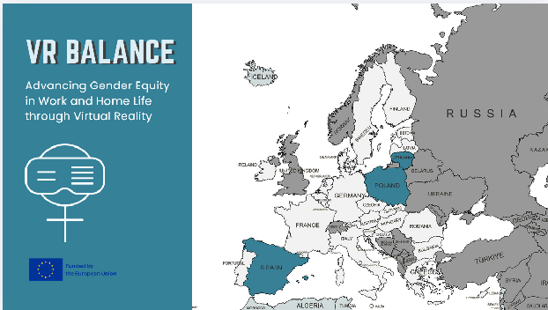
Welcome everybody to the VR Balance project. This project aims to explore gender imparities from its roots, understand social constructs of gender and the implications it has had in the way we live nowadays, and overall to encourage you to flip the script in order to make a more equal and sustainable society for all.
This project has been funded by the European Union CERV´s program, and is the result of a collaboration plan between three organizations from three different countries: The Female Entrepreneurship Foundation from Poland, The Social Innovation Found from Lithuania, and The University of Barcelona in association with MetaMedics VR.
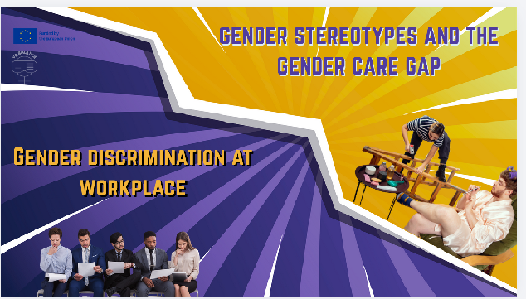
Along this presentation, we will address two main topics: On one hand the effects of Gender Stereotypes in the Gender Care Gap: where do these stereotypes come from and what do they determine in terms of gender gap in caring; and on the other hand the Gender discrimination at the workplace, examining the consequences of these dynamics, including the loss of talent and the erosion of workplace culture, affecting wellbeing, innovation, and fairness.
Open questions before developing the topics:
-Who believes their workplace is fully merit based?
-Who thinks that their access for education was equal between men, women and other identities?
-Who believes that has been raised under gender equality dynamics, therefore has not been exposed to gender discrimination at home?
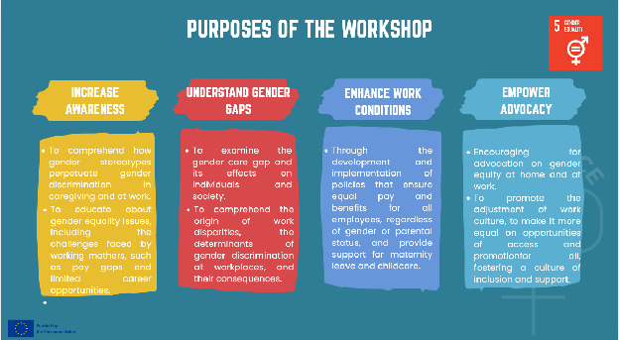
The VR Balance training is framed under the following Educational Aims. Our goal is to raise awareness, foster discussion, and develop actionable solutions to combat gender discrimination in caregiving and at work.
The purposes of the workshops are (read slide).
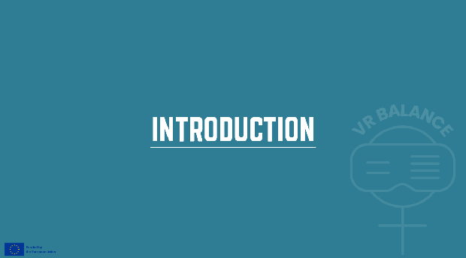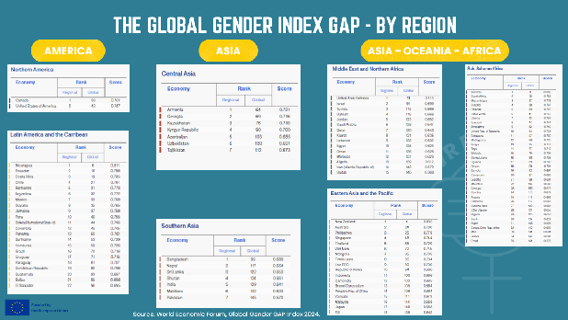
Let’s begin by seeing some statistics. These are the results of the global Gender Gap Index which is a metric published by the World Economic Forum that measures gender equality across countries in four areas: economic participation, education, health, and political empowerment.
Here you can see a distribution of the ranking, by continent. I would like to highlight a few interesting data:
-Nicaragua, a central American country, is placed at the 6th place.
-Sudan and Pakistan are placed in 145th and 146th position.
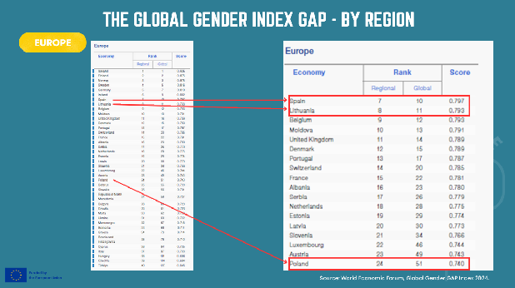
Iceland, Finland and Norway compose the top 3 worldwide and by region.
Spain and Lithuania are rank at the 10th and 11th place each, while Poland is placed at the 51st place global. The first two may seem not to present important differences whereas Poland might have differences as is placed 4 times lower. So, let’s see in detail what is being considered to justify Spain ranking.
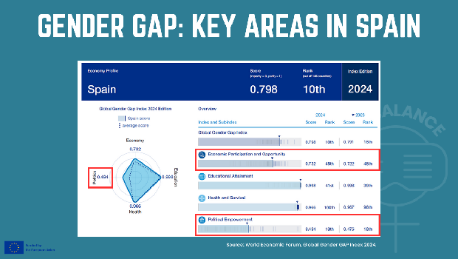
As we can appreciate, there are not big differences between the scores obtained in terms of Educational Attainment and Health and Survival from year 2023 to 2024. However, regarding Economic Participation the score similar. But where the most significant difference lies is in the Political Empowerment parameter, decreasing during the last year.
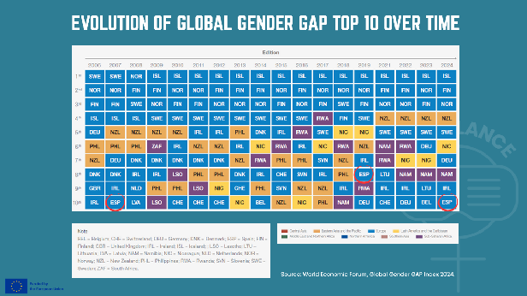
As these parameters change constantly, there is plenty of room for grow and improvement. This table depicts the top 10 countries with the best score in terms of Gender Gap in the last 18 years, and we can see Spain reaching the 10th position over 2024, after being ranked 8th in 2019.
The question here is, how do we maintain this position, or even better, demonstrate progress in the matter?
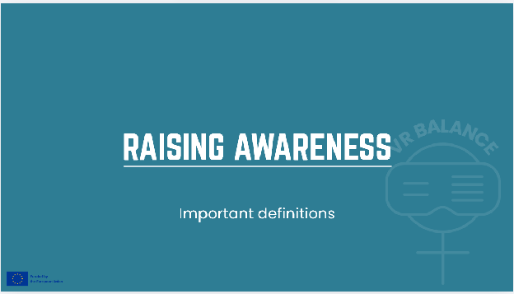
Gender stereotypes significantly influence caregiving roles and disparities in the workplace, often leading to gender discrimination. By understanding these stereotypes and their impact, we can work towards a more equitable distribution of duties and responsibilities in society. In order to meet the goal of the workshop, we will now go through some important definitions.
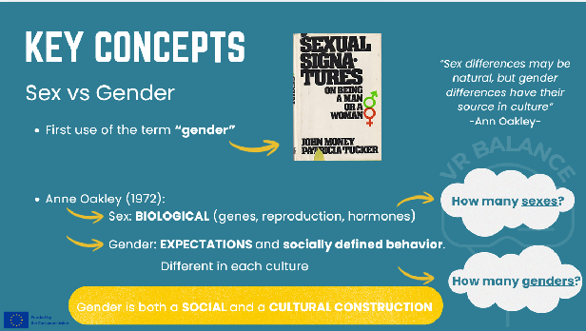
Firstly, it is necessary to understand the difference between the notions of sex and gender. Also, the origin of the term gender and, especially, to emphasize the constructed nature of gender. The anthropologist Anne Oackley first made the distinction between sex based on biological traits, and gender, which is both a social and a cultural construction. So, we may wonder about how many sexes there are (keeping in mind intersex) and how many genders there can be.
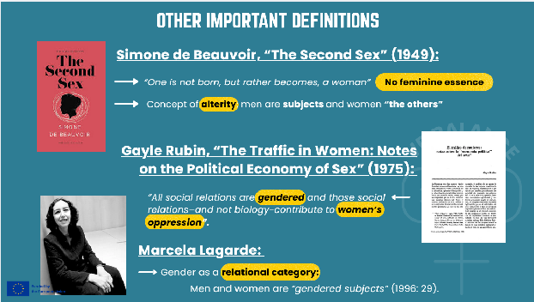
There are many definitions of gender, here we can see some of the classic ones by relevant experts on women’s and gender studies.
Simone de Beauvoir is a key reference, since she was the first one who defied the existence of any essence related to being a woman, and named women as “the others” of men, promoting the concept of alterity.
Another anthropologist, Gayle Rubin, considered that social relations determined women’s oppression, negating biology as a crucial factor.
Much later, Marcela Lagarde explained the relational category that gender actually is. We are all gendered subjects.
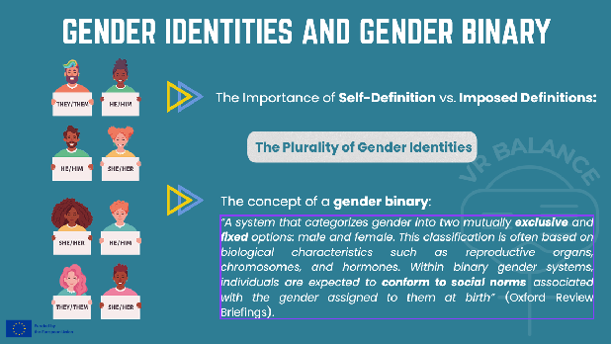
It is also important to understand the plurality of gender identities and how this plurality goes beyond the patriarchal gender binary. The gender binary dictates only two possible options for gendered identities, and thus all the gender mandates associated to either male of female identities that we are all assigned when we are born.
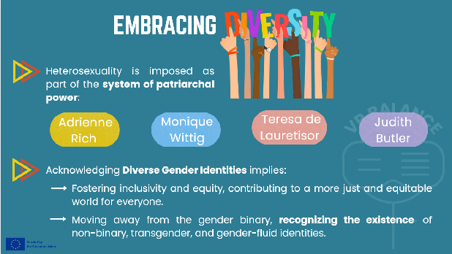
In terms of sexuality, the imposed heterosexuality should be discarded, as many diverse gender identities exist such as non-binary, trans or genderfluid people, among others. This is the reason why it is crucial to acknowledge and embrace diversity, which promotes a more just world where everyone is included.
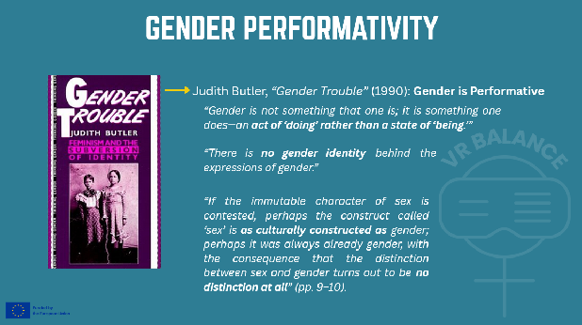
As explained by Judith Butler, gender is also performative, that is, something to perform, to do. She thus negates any essence to gender and even to sex too. What is important is how we decide to perform our gender, going beyond imposed social definitions. As a consequence, many people adopt diverse gender representations.
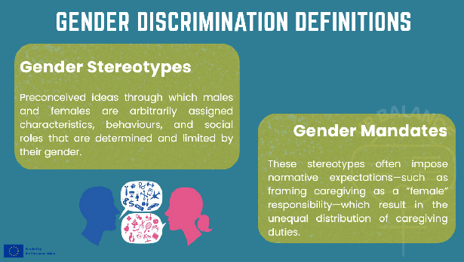
Now we address the notion of binary gender stereotypes as they are assigned to men and women. One of the consequences of these stereotypes is gender mandates, among which caregiving is regarded as a female mandate, a female responsibility.
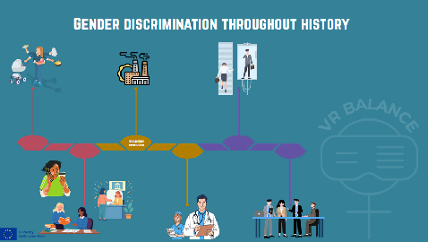
If we look at the history of work through a timeline, we can see that gender inequality does not begin because women did not work, but rather because their work was historically placed in a different position. In pre-industrial societies, both women and men worked, but under a sexual division of labor: women were primarily assigned caregiving, domestic, and life-sustaining tasks, while men were associated with productive, paid, and socially visible work. These caregiving tasks—essential for the survival of communities—were not recognized as work, either economically or socially.
Over time, this division became institutionalized. For centuries, women faced legal restrictions on access to education, property, and economic autonomy, reinforcing their dependence on the private sphere. When industrialization emerged, rather than breaking with this model, it deepened it: work became physically separated from the home, the figure of the male breadwinner and the female caregiver was consolidated, and when women entered the labor market in large numbers, they did so in feminized sectors, with lower pay and less recognition.
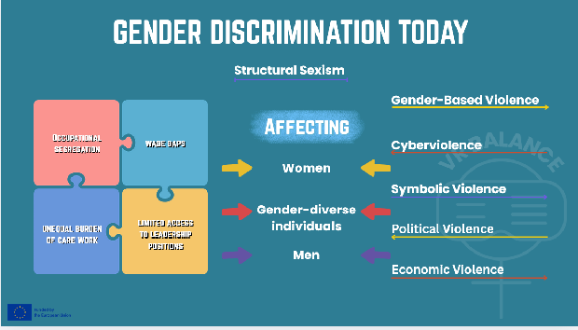
This historical model has not disappeared over time, and it has built what we know as Structural Sexism.
Their effects are represented in the following image. To the right we see the effects at work culture, in the form of occupational segregation, wage gaps, an unequal burden of care work, and limited access to leadership positions—even in fields such as health and education, where women are the majority but do not always hold the same decision-making power. Understanding this historical trajectory allows us to recognize that current inequalities are neither accidental nor individual, but rather the result of structures that have been built and reproduced over time.
In the right, we see a list of attitudes that rest under the normal social functioning. These are forms of gender discrimination. Here there is a list of the most visible ones which come from the fact that sexis is structural in a patriarchal society.
- Gender‑Based Violence encompasses multiple forms of harm rooted in unequal power relations:
  - Physical violence: murders, beatings, feminicides, and other forms of bodily harm.
  - Psychological violence: humiliation, insults, silencing, intimidation, and invisibilization.
  - Sexual violence: rape, sexual abuse, genital mutilation, and other forms of sexual coercion.
- Cyberviolence: harassment, threats, hate speech, and abuse in digital spaces.
- Symbolic Violence reinforces inequality through cultural and social norms, including:
  - The use of non‑inclusive language.
  - The perpetuation of gender stereotypes
- Political Violence
  - Threats: intimidation, harassment, and coercion aimed at discouraging political participation or silencing voices.
  - Smear campaigns: disinformation, reputational attacks, and public defamation, often targeting credibility and legitimacy.
- Economic Violence
  - Gender wage gap: systematic differences in earnings between men and women.
  - Glass ceiling vs. sticky floor: invisible barriers that prevent career advancement versus structural conditions that trap individuals in low‑paid, precarious positions.
  - Gender employment gap: unequal access to employment opportunities and job stability.
  - Gender retirement gap: disparities in pensions and retirement income resulting from lifelong inequalities.

Gender discrimination can affect anyone, but historically, women are the most affected in average, gender-diverse individuals often face compounded invisibility that excludes them from society and; even though men may benefit structurally from this phenomenon, they also face norm-based penalties.
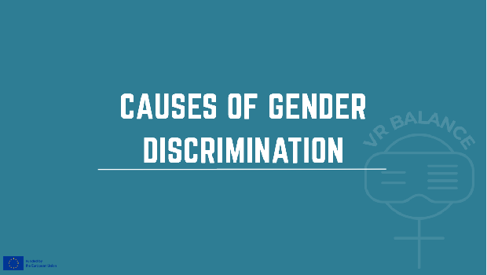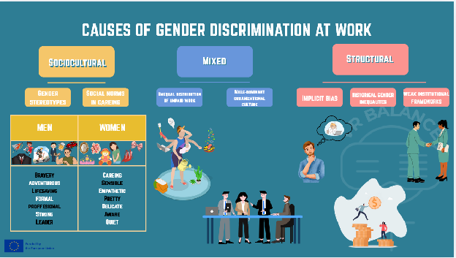
1. Sociocultural:
Job roles respond to social norms. These norms recognize gender roles and gender stereotypes, defining what is appropriate to each gender.
Where can we see these social norms? We are exposed to them since birth, and they accompany us through life, being present in our environment and on social expectations. (Use the table as an example of the construction of the social norm. The icons are the input of what we are exposed to regarding our sex, and below there are characteristic associated to them. These characteristics build the gender stereotype, and thus the gender role that will be reinforcing a future occupation.)
Example:
-Gender stereotypes 🡪 Beliefs about “female” and “male” abilities and characteristics.
-Social norms around caregiving roles 🡪 Expectation that women assume primary caregiving responsibilities.
*What if you don’t fit the gender? What if you don’t align with your expected gender role? You get to be categorized as odd and then excluded.
2. Institutional/Structural:
Refers to systemic, built-in features of organizational systems that produce and reproduce inequalities regardless of individual intentions.
Examples of these are:
-Implicit bias 🡪 Unconscious prejudices in decision-making.
-Historical gender inequalities 🡪 Accumulated gaps in human capital and networks.
-Weak institutional frameworks 🡪 Lack of regulation or enforcement.
3. Mixed:
Are those that get both socioculturaly and structuraly influenced.
-Unequal distribution of unpaid work 🡪 Disproportionate burden of domestic and care work.
-Male-dominant organizational culture 🡪 Workplace norms designed around male career patterns.
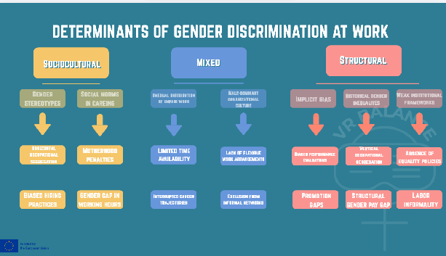
From these causes emerge various drivers of discrimination that are used to determine the impact of inequalities, understanding how the cause operates.
Examples of these are: (name just a few)
-Horizontal occupational segregation 🡪 Women concentrated in care, education, and service occupations.
-Biased hiring practices 🡪 Preference for men in STEM or technical occupations.
-Motherhood penalty 🡪 Lower wages or fewer promotions after maternity.
-Gender gap in working hours 🡪 Higher prevalence of part-time work among women.
-Limited time availability 🡪 Reduced access to managerial positions.
-Interrupted career trajectories 🡪 Temporary exits from the labor market.
-Lack of flexible work arrangements 🡪 Long working hours incompatible with caregiving.
-Exclusion from informal networks 🡪 Key decisions made in male-dominated social spaces.
-Biased performance evaluations 🡪 Women perceived as having lower leadership potential.
-Promotion gaps 🡪 Lower access to senior and executive positions.
-Vertical occupational segregation 🡪 “Glass ceiling” in higher hierarchical levels.
-Structural gender pay gap 🡪 Persistent wage differences despite similar qualifications.
-Absence of equality policies 🡪 No harassment protocols or pay transparency measures.
-Labor informality 🡪 Higher female concentration in precarious employment.
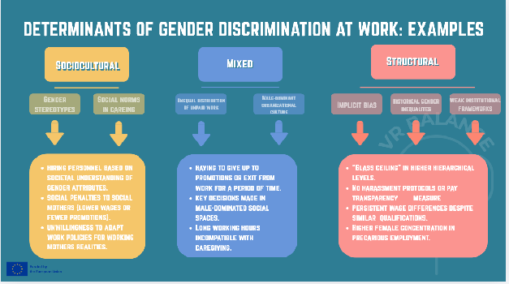
Examples slide:
SOCIOCULTURAL: hiring personnel based on societal understanding of gender attributes; social penalties to social mothers (lower wages or fewer promotions); unwillingness to adapt work policies for working mothers realities.
MIXED: having to give up to promotions or exit from work for a period of time. Key decisions made in male-dominated social spaces.
STRUCTURAL: “Glass ceiling” in higher hierarchical levels; No harassment protocols or pay transparency measures; 🡪 Persistent wage differences despite similar qualifications.

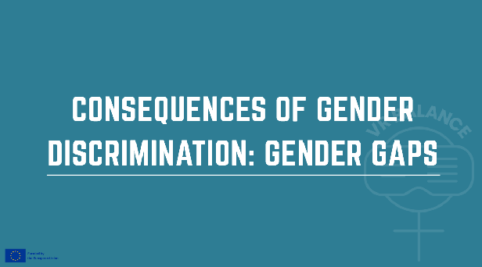
La consecuencia principal de la discriminación de género son las brechas de género.
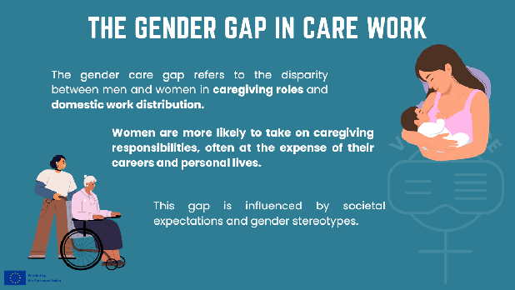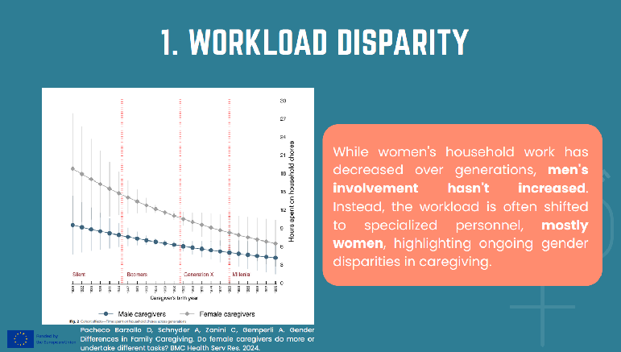
On another example, here we see a graphic that shows the Workload Disparity between men and women.
Despite a decrease in household work among women across generations, this reduction does not correspond to an increase in household work among men. Instead, the workload is often shifted to specialized personnel, who are predominantly women. These women bear the burden of household tasks for working women, highlighting a persistent gender disparity. The lack of increased involvement from men in household duties underscores the need for greater gender equity in caregiving responsibilities.
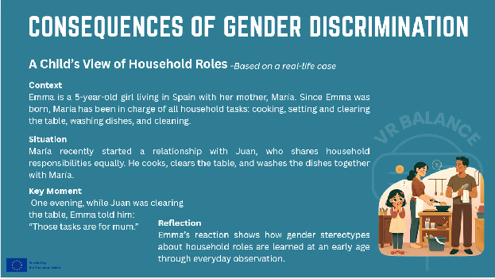
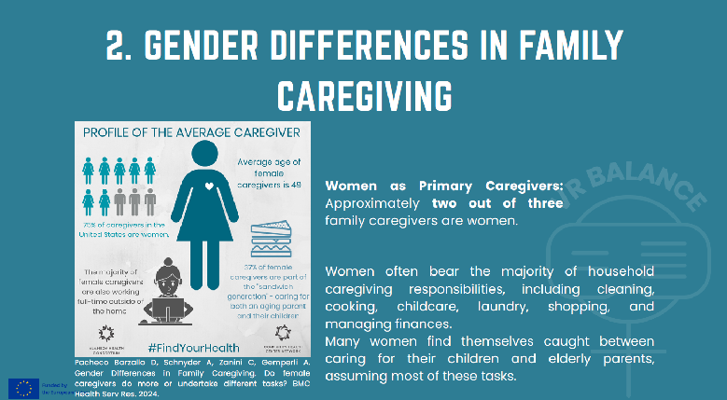
Now we will go through some examples that demonstrate the burden that lies on women who provide care.
Reflection on Women's Household Caregiving Tasks
Women often bear the majority of household caregiving responsibilities, which can include a wide range of tasks. These typically involve:
Cleaning: Maintaining the cleanliness of the home, including dusting, vacuuming, and mopping.
Cooking: Preparing meals for the family, which can be time-consuming and require planning.
Childcare: Taking care of children, including feeding, bathing, and helping with homework.
Laundry: Washing, drying, and ironing clothes.
Shopping: Purchasing groceries and other household necessities.
Managing household finances: Budgeting and paying bills.
Despite societal progress, these tasks often fall disproportionately on women, highlighting the need for more equitable distribution of household responsibilities.

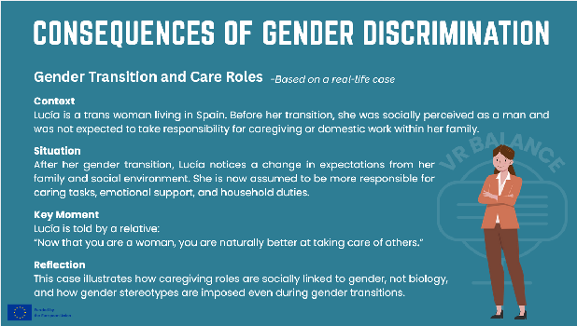
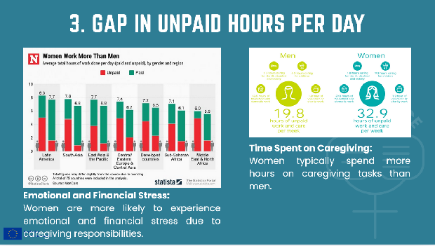
Describe the global phenomenon of women working significantly more than men without being paid.

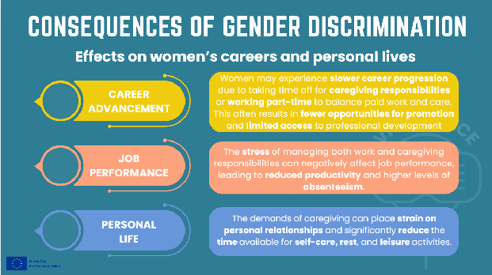
In summary, the principal consequences of gender discrimination for women include reduced career advancement opportunities, diminished productivity and job performance, and a deterioration in overall quality of life.
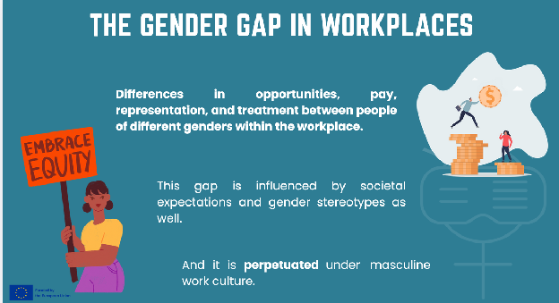
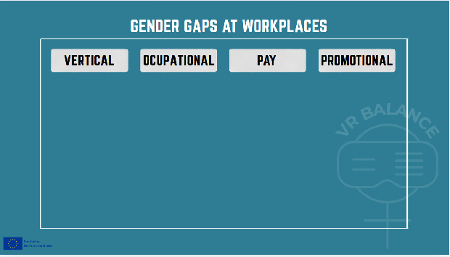
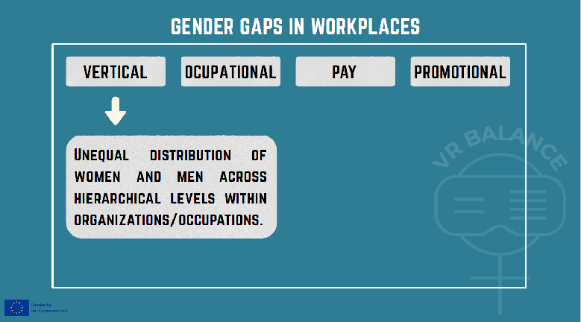
At the workplace, there are 4 main Gender gaps to pay attention to:
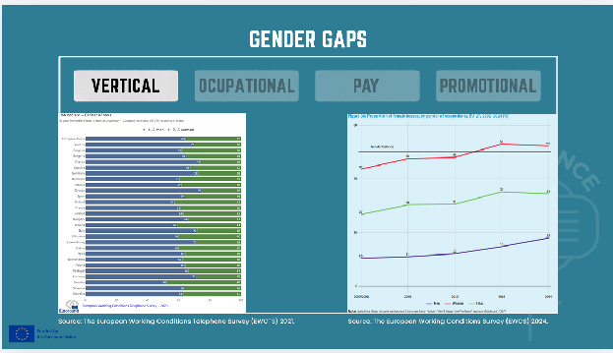
-Vertical gap: which is the unequal distribution of women and men across hierarchical levels within organizations/occupations.
Data from The European Working Conditions Telephone Survey (EWCTS) 2021 showed that almost a 1/3 of the manager positions of the people asked, where men.
Data from The European Working Conditions Survey (EWCS) 2024 indicates:
Minimal progress has been made towards gender balance at management level over the past 25 years. The proportion of female managers increased from 27 % in the 2000/2001 survey to 34 % in 2024 (Figure 36). However, female managers continue to be concentrated in female-dominated workplaces, where gender composition of immediate bosses has reached parity. Women are hereby much more likely to have a female boss (52 %) than men are (18 %).
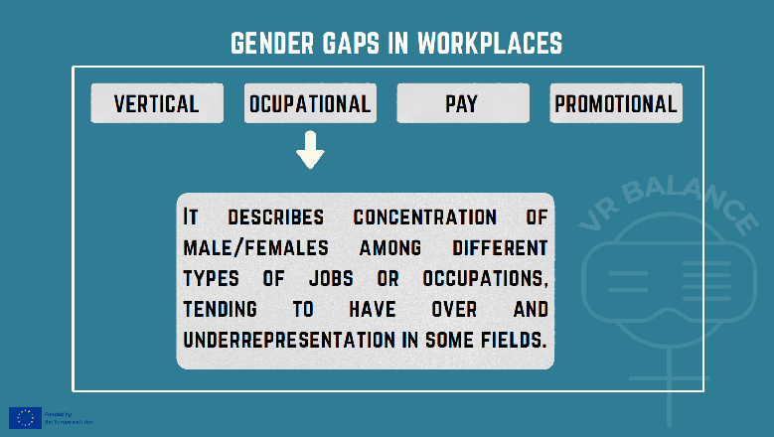
-Horizontal/Occupational gap: which describes concentration of male/females among different types of jobs or occupations, tending to have over and underrepresentation in some fields.
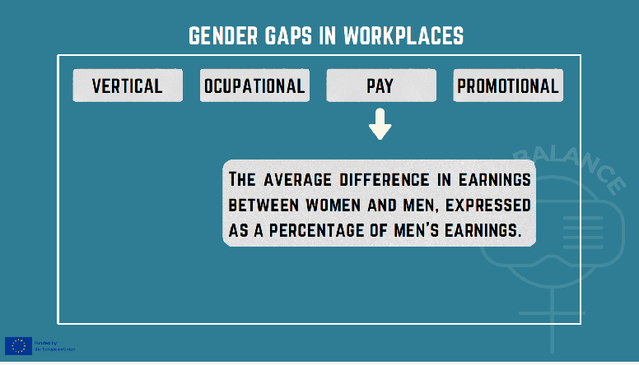
-Pay gap: refers to the average difference in earnings between women and men, expressed as a percentage of men’s earnings.
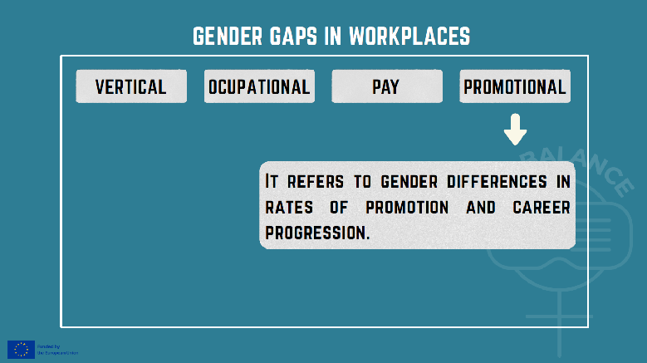
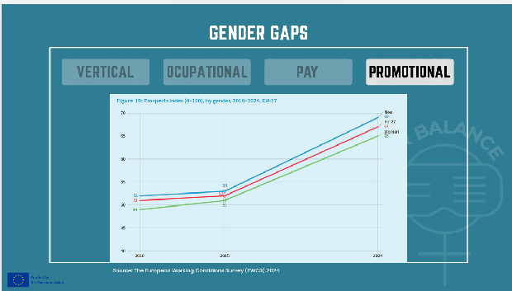
-Promotional gap: refers to gender differences in rates of promotion and career progression.
Progress over time: Two of the items in the Prospects index that can be used to examine trends over time are career prospects and job security (which addresses fear of job loss). In the context of a much-improved labour market, the Prospects index has improved significantly since 2010 for both men and women. However, the gender gap has increased since 2015 (Figure 19).
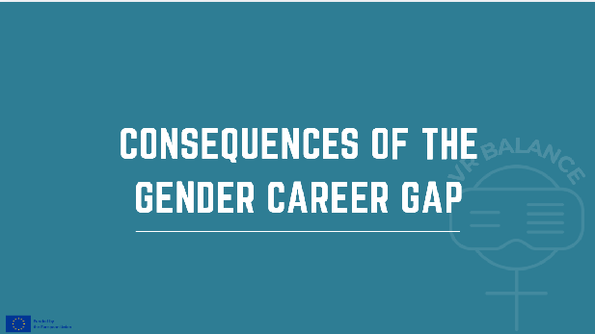
there are Individual, organizational and societal consequences of the gender gap, and that together impact drastically on the economy.
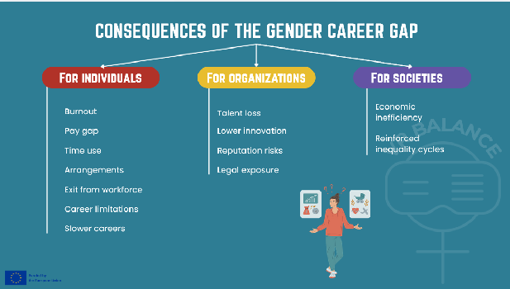
For Individuals
- Slower careers/ Career limitations
- Burnout: Time use: also associated with family and child care; Caring jobs: elderly and disabled people
- Self-censorship
- Exit from workforce
- Pay gap: pay gap and marital status
- Arrangements: flexible hours of work
For Organizations
- Talent loss
- Lower innovation
- Reputation risks
- Legal exposure
For Society
- Economic inefficiency
- Reinforced inequality cycles
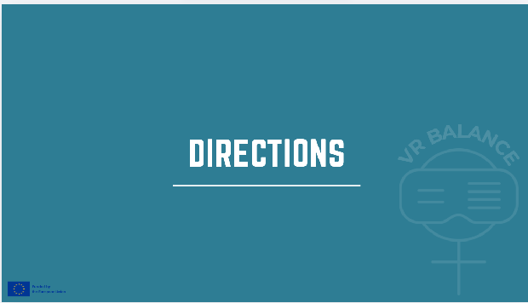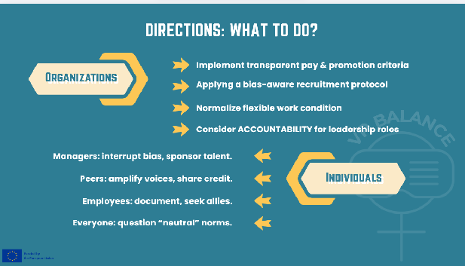
6.2 What Organizations Can Do
- Transparent pay & promotion criteria
- Bias-aware recruitment
- Flexible work normalization
- Accountability for leadership
6.3 What Individuals Can Do (by role)
- Managers: interrupt bias, sponsor talent
- Peers: amplify voices, share credit
- Employees: document, seek allies
- Everyone: question “neutral” norms
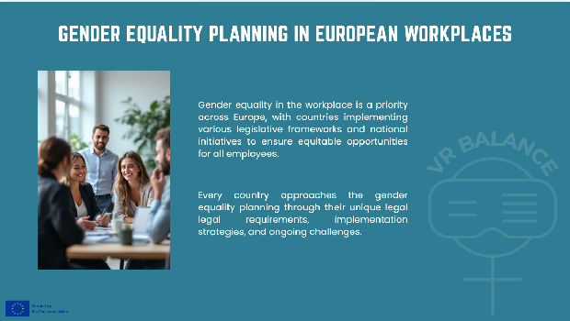
Gender equality in the workplace is a priority across Europe, with countries implementing various legislative frameworks and national initiatives to ensure equitable opportunities for all employees.
Every country approaches the gender equality planning through their unique legal legal requirements, implementation strategies, and ongoing challenges.
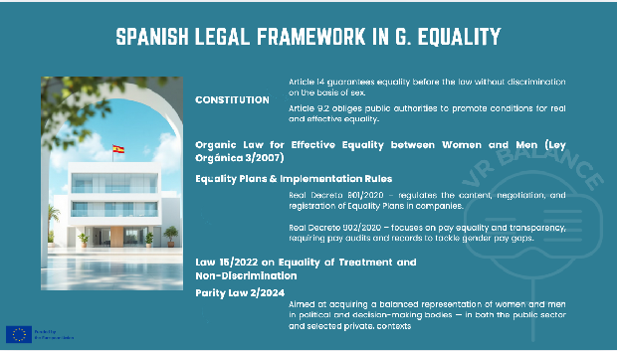
1- Constitution of Spain, through different articles dictates:
Article 14 guarantees equality before the law without discrimination on the basis of sex.
Article 9.2 obliges public authorities to promote conditions for real and effective equality.
2- Organic Law for Effective Equality between Women and Men (Ley Orgánica 3/2007)
It establishes: The principle of equal treatment and opportunities; Obligations for employers and public administrations to prevent discrimination and promote equality; Mandatory Equality Plans for companies with a certain number of employees; Measures against sexual harassment and discriminatory practices.
3- Equality Plans & Implementation Rules: Two Royal Decrees implement and regulate workplace equality obligations under the 2007 law:
Real Decreto 901/2020 – regulates the content, negotiation, and registration of Equality Plans in companies.
Real Decreto 902/2020 – focuses on pay equality and transparency, requiring pay audits and records to tackle gender pay gaps.
4- Law 15/2022 on Equality of Treatment and Non-Discrimination
Broader legal protection against discrimination on various grounds, including gender, in employment, education, access to goods/services, and public life. It complements the Organic Equality Law by strengthening anti-discrimination guarantees.
5- Parity Law 2/2024
Aimed at acquiring a balanced representation of women and men in political and decision-making bodies — in both the public sector and selected private contexts. It implements EU requirements about gender balance and extends them beyond the minimum thresholds.
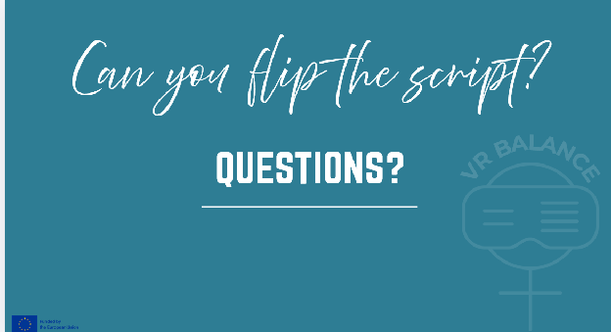
Remember this: “Discrimination often operates without intent.”
Then start with the activities.

