Workshop 1
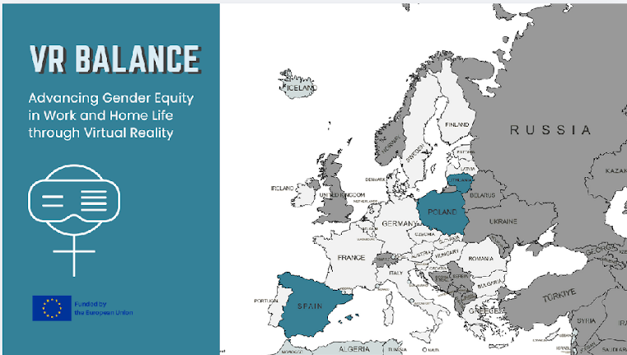
Welcome everybody to the first out of three presentations that compose the VR Balance project. As you all may know, this project aims to explore gender imparities from its roots, understand social constructs of gender and the implications it has had in the way we live nowadays, and encourage you to flip the script in order to make a more equal and sustainable society for all.
This project has been funded by the European Union CERV´s program, and is the result of a collaboration plan between three organization from three different countries: The Female Entrepreneurship Foundation from Poland, The Social Innovation Found from Lithuania, and The University of Barcelona in association with MetaMedics VR.
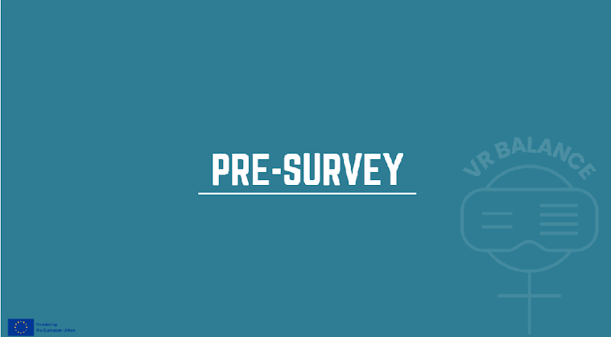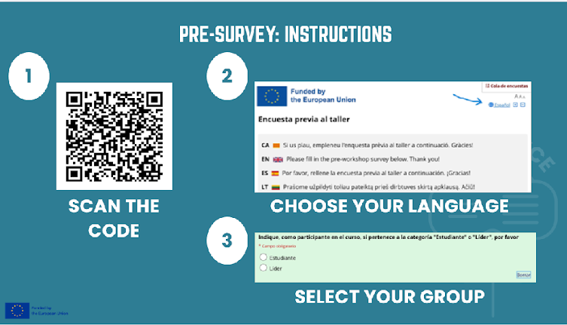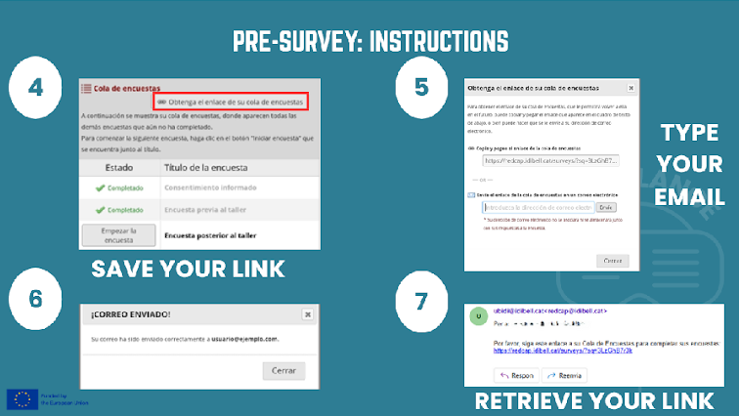
Explain the surveys. They will be used to assess our understanding and attitudes towards this topic. “As for now, please scan the QR code with your phones and follow the instructions to answer the Pre-survey. Please, mind to be absolutely honest. Be aware that very often, the first answer that comes to our mind is the sincerest. Thank you”.
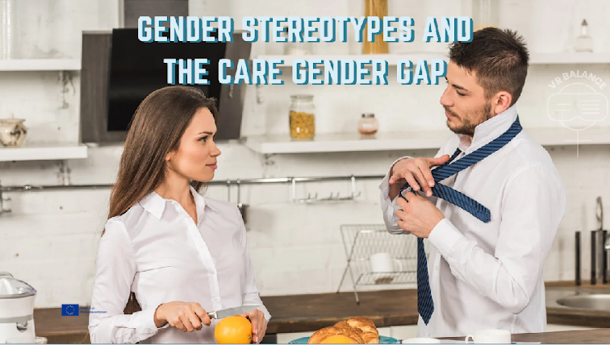
Today we will be addressing the relationships between the Gender Stereotypes and the Care Gender Gap: Causes of Gender Discrimination in Caregiving. We will do so by exploring the significant impact that gender stereotypes and the gender gap have on caregiving roles.
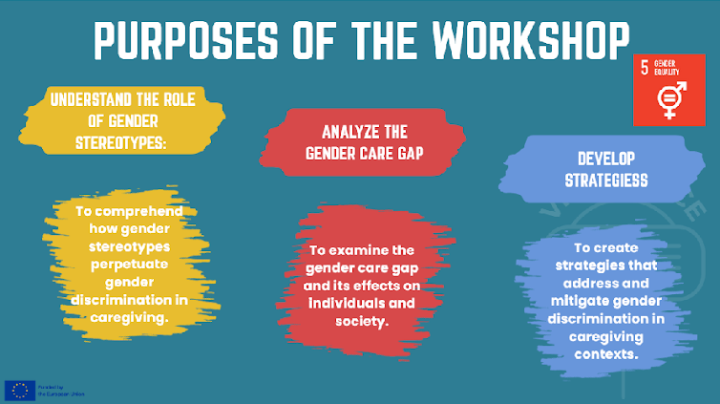
The VR Balance training is framed under the following Educational Aims. Our goal is to raise awareness, foster discussion, and develop actionable solutions to combat gender discrimination in caregiving.
Thank you.
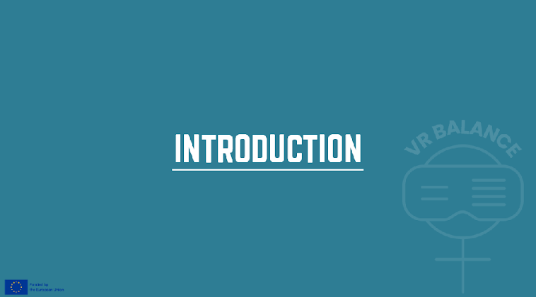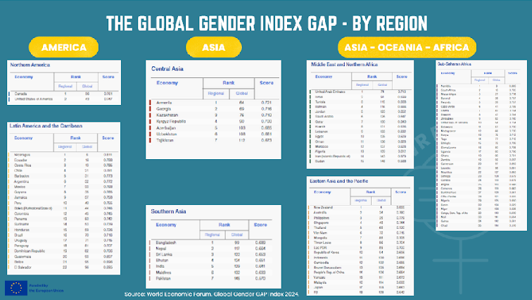
Let’s begin by looking at some statistics. These are the results of the Global Gender Gap Index, an indicator published by the World Economic Forum that measures gender equality among countries in four areas: economic participation, education, health, and political empowerment.
Here you can see the distribution of the ranking by continent. I would like to highlight some interesting data:
- Nicaragua, a country in Central America, ranks sixth.
- Sudan and Pakistan are in positions 145 and 146, respectively.
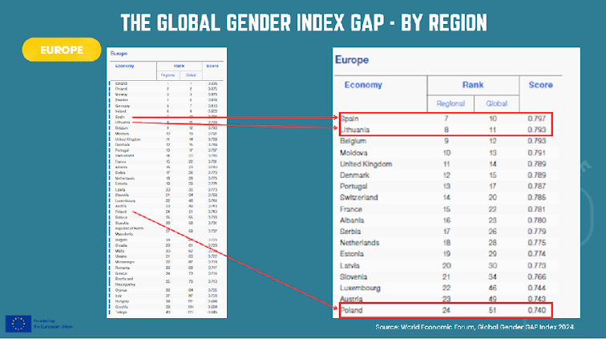
Iceland, Finland, and Norway make up the top 3 both globally and regionally.
Spain and Lithuania rank 10th and 11th respectively, while Poland holds the 51st position worldwide. The first two may not appear to show significant differences, whereas Poland could display greater disparities as it is ranked four times lower in the classification.
So let’s take a closer look at the aspects considered to justify Spain’s position in the ranking.
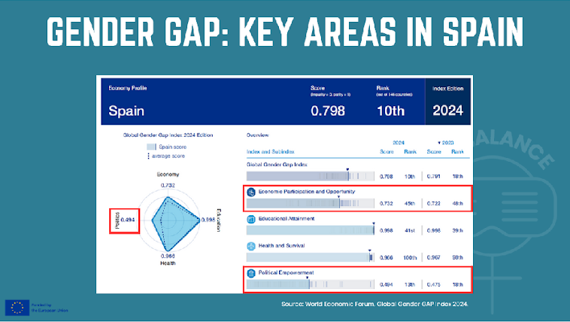
This image shows a comparison of Spain’s ranking and gender gap index between 2023 and 2024. The closer the index is to 1, the smaller the gap both by area and overall. For example, according to these data, Spain has closed 79.8% of the gender gap overall.
As we can see, there are no major differences between the scores in the areas of Educational Attainment and Health and Survival from 2023 to 2024. In terms of Economic Participation, the score is also similar.
However, the most significant difference can be observed in the Political Empowerment parameter, which has improved slowly over the past year.
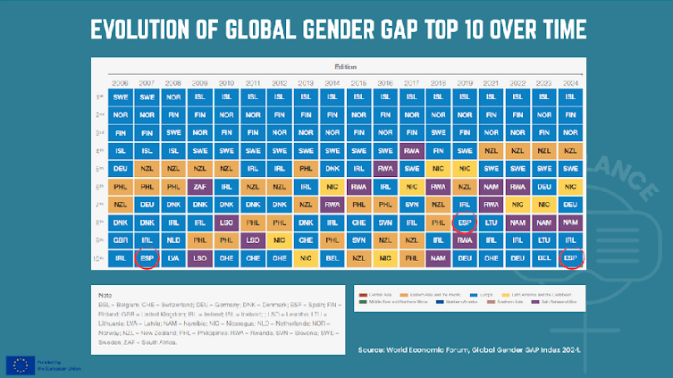
Since these parameters are constantly changing, there is significant room for growth and improvement. This table shows the 10 countries with the highest scores in terms of gender gap over the past 18 years, and we can see that Spain reaches 10th place in 2024, after having ranked 8th in 2019.
The question here is, how do we maintain this position, or even better, demonstrate progress in the matter?
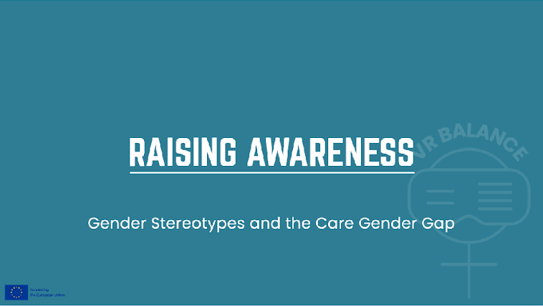
Gender stereotypes significantly influence caregiving roles and inequalities in the workplace, often leading to gender discrimination. By understanding these stereotypes and their impact, we can move toward a more equitable distribution of duties and responsibilities in society.
To achieve the objective of the workshop, we will now review some important definitions.
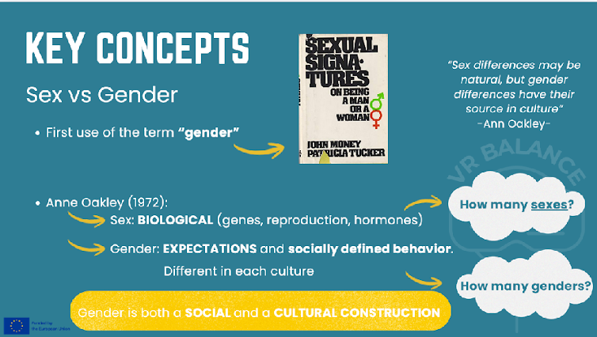
First, it is necessary to understand the difference between the concepts of sex and gender, particularly by emphasizing the socially constructed nature of the latter. The anthropologist Anne Oakley was the first to distinguish between sex, which is based on biological characteristics, and gender, which is both a social and cultural construct, in an academic context.
Thus, we may ask how many sexes exist (taking into account intersex conditions) and how many genders can exist.
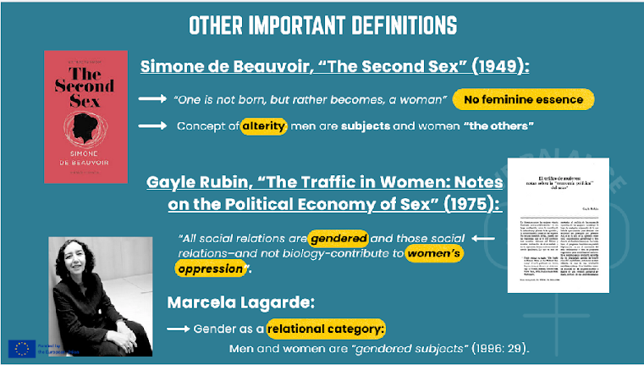
There are many definitions of gender, here we can see some of the classic ones by relevant experts on women’s and gender studies.
Simone de Beauvoir is a key reference, since she was the first one who defied the existence of any essence related to being a woman, and named women as “the others” of men, promoting the concept of alterity.
Another anthropologist, Gayle Rubin, considered that social relations determined women’s oppression, negating biology as a crucial factor.
Much later, Marcela Lagarde explained the relational category that gender actually is. We are all gendered subjects.
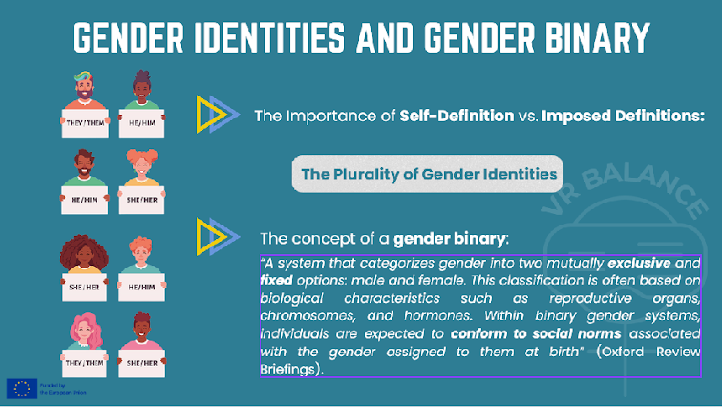
With this in mind, and recalling the previous question—how many genders are there? Or rather, how many genders are recognized?—we can further reflect on how much space is allowed for self-definition of gender versus imposed definitions of gender.
This opens the conversation to the existence of a plurality of gender identities. A plurality that goes beyond the patriarchal gender binary. The gender binary establishes only two possible options for gender identities, along with all the gender norms associated with masculine or feminine identities that are assigned to us at birth.
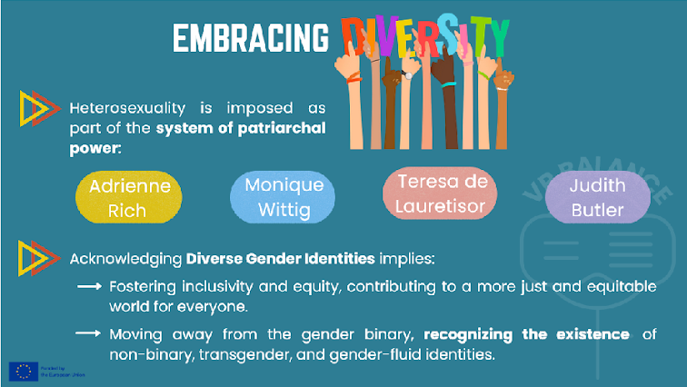
In terms of sexuality, the imposed heterosexuality should be discarded, as many diverse gender identities exist such as non-binary, trans or genderfluid people, among others. This is the reason why it is crucial to acknowledge and embrace diversity, which promotes a more just world where everyone is included.
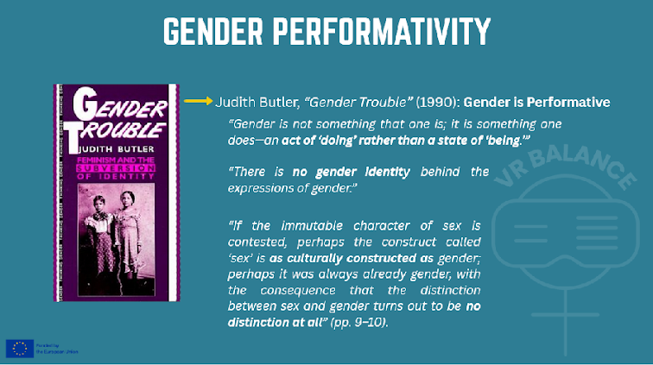
One example is this author, who introduces the concept of gender performativity. That is, it is something that is done and therefore lacks any inherent essence in both gender and sex. In this way, we open the discussion to the concepts of gender identity versus gender expression.
As Judith Butler explains, gender is also performative—that is, something that is enacted, something that we do. In this sense, Butler rejects any fixed essence of both gender and sex. What matters is how we choose to perform our gender, going beyond socially imposed definitions. As a result, many people adopt diverse forms of gender expression.
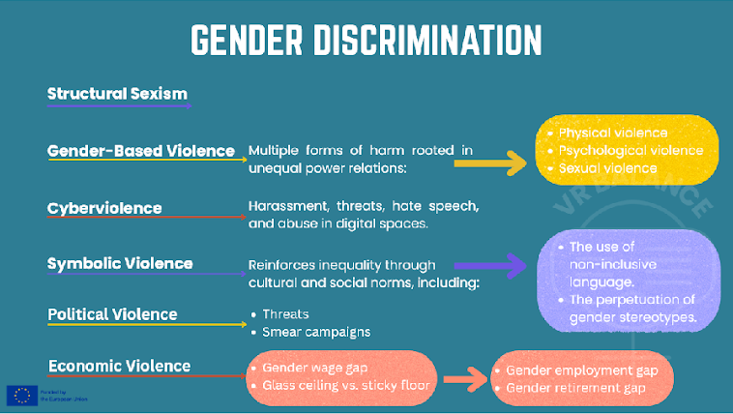
Unfortunately, there are also many possible forms of gender discrimination. Here there is a list of the most visible ones which come from the fact that sexis is structural in a patriarchal society.
Especially the worst kind is gender violence that can be physical, which we can see everyday in the many cases of gender violence in our country and all around. In 2025 45 women were killed by their partners or ex-partners only in Spain.
But this is only the most brutal consequence of gender discrimination, which we can find everywhere, such as cyberviolence, polítical violence or economic violence. In this course we are going to focus on one type of gender discrimination which is the care gender gap.
- Structural Sexism
- Gender‑Based Violence encompasses multiple forms of harm rooted in unequal power relations:
  - Physical violence: murders, beatings, feminicides, and other forms of bodily harm.
  - Psychological violence: humiliation, insults, silencing, intimidation, and invisibilization.
  - Sexual violence: rape, sexual abuse, genital mutilation, and other forms of sexual coercion.
- Cyberviolence: harassment, threats, hate speech, and abuse in digital spaces.
- Symbolic Violence reinforces inequality through cultural and social norms, including:
  - The use of non‑inclusive language.
  - The perpetuation of gender stereotypes
- Political Violence
  - Threats: intimidation, harassment, and coercion aimed at discouraging political participation or silencing voices.
  - Smear campaigns: disinformation, reputational attacks, and public defamation, often targeting credibility and legitimacy.
- Economic Violence
  - Gender wage gap: systematic differences in earnings between men and women.
  - Glass ceiling vs. sticky floor: invisible barriers that prevent career advancement versus structural conditions that trap individuals in low‑paid, precarious positions.
  - Gender employment gap: unequal access to employment opportunities and job stability.
  - Gender retirement gap: disparities in pensions and retirement income resulting from lifelong inequalities.

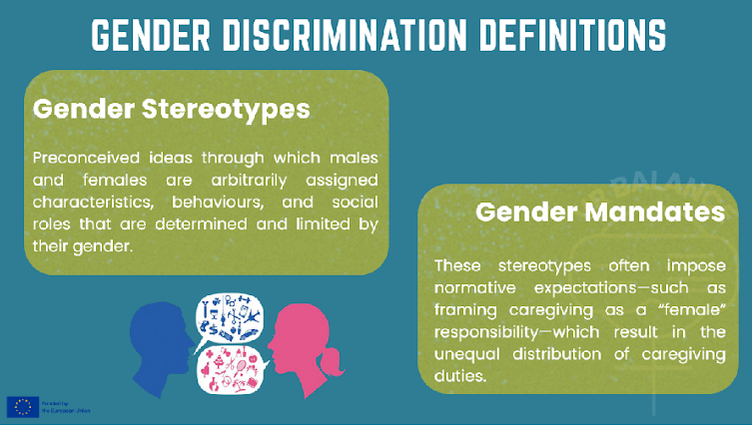
Finally, we have gender stereotypes, which are preconceived ideas based on the gender binary through which men and women are arbitrarily assigned characteristics, behaviors, and social roles. One of their consequences is gender norms, that is, the normative expectations associated with gender.
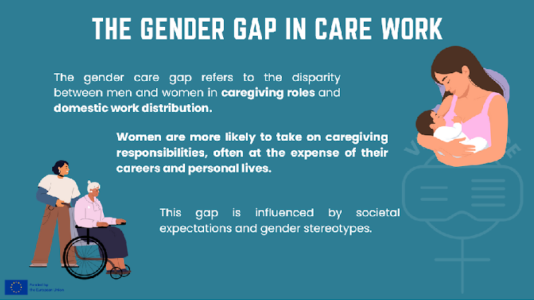
(Read the slide)
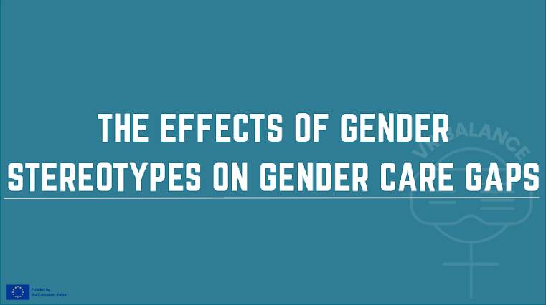
Let’s address the effects of the Gender Stereotypes on Gender Care Gaps.
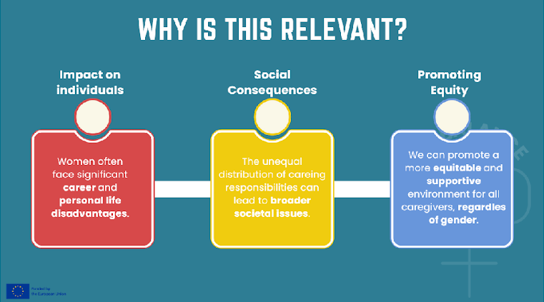
This topic is important because in reality caregivers experience different levels of inequity:
Impact on Individuals: Women often face significant career and personal life disadvantages due to the disproportionate caregiving burden.
Societal Consequences: The unequal distribution of caregiving responsibilities can lead to broader societal issues, including economic disparities and reduced workforce participation.
Promoting Equity: By challenging these stereotypes and closing the care gender gap, we can promote a more equitable and supportive environment for all caregivers, regardless of gender.

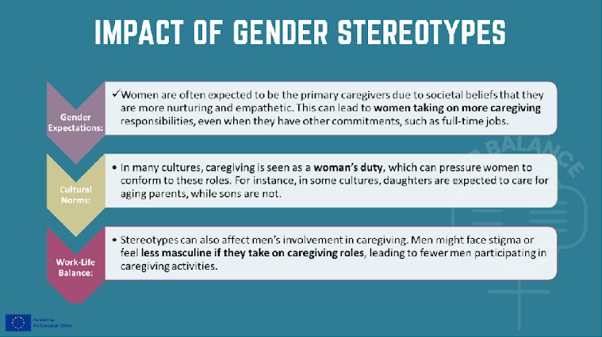
(Read the slide)
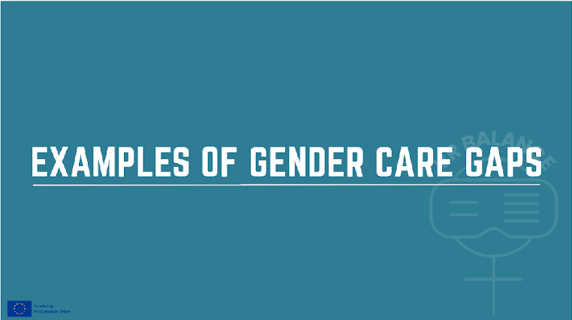
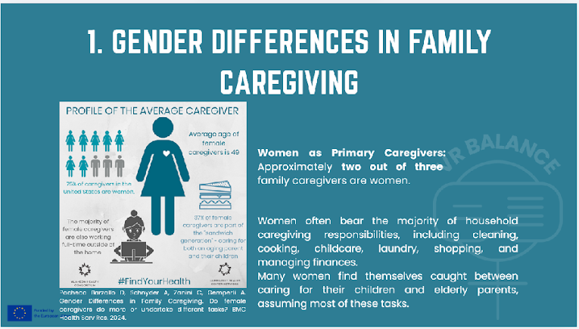
Now we will go through some examples that demonstrate the burden that lies on women who provide care.
Reflection on Women's Household Caregiving Tasks
Women often bear the majority of household caregiving responsibilities, which can include a wide range of tasks. These typically involve:
Cleaning: Maintaining the cleanliness of the home, including dusting, vacuuming, and mopping.
Cooking: Preparing meals for the family, which can be time-consuming and require planning.
Childcare: Taking care of children, including feeding, bathing, and helping with homework.
Laundry: Washing, drying, and ironing clothes.
Shopping: Purchasing groceries and other household necessities.
Managing household finances: Budgeting and paying bills.
Despite societal progress, these tasks often fall disproportionately on women, highlighting the need for more equitable distribution of household responsibilities.
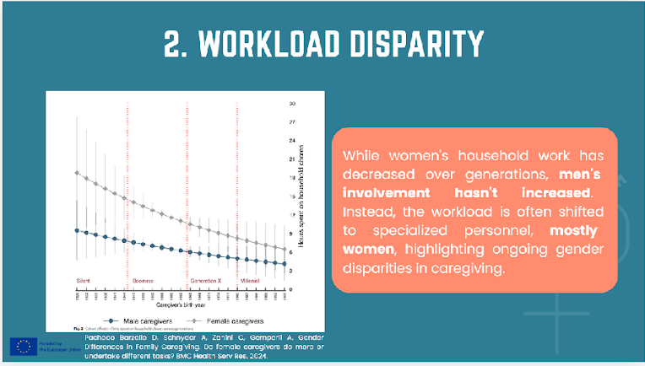
On another example, here we see a graphic that shows the Workload Disparity between men and women.
Despite a decrease in household work among women across generations, this reduction does not correspond to an increase in household work among men. Instead, the workload is often shifted to specialized personnel, who are predominantly women. These women bear the burden of household tasks for working women, highlighting a persistent gender disparity. The lack of increased involvement from men in household duties underscores the need for greater gender equity in caregiving responsibilities.
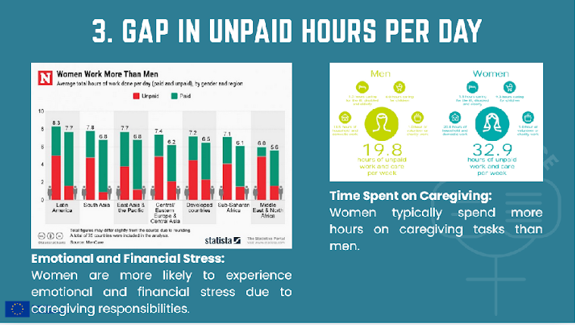
Finally, we must mention a global phenomenon: women work significantly more hours than men without receiving pay. A large part of this work consists of unpaid domestic and care work, which sustains the functioning of families and the economy as a whole, yet is rarely recognized or economically valued.
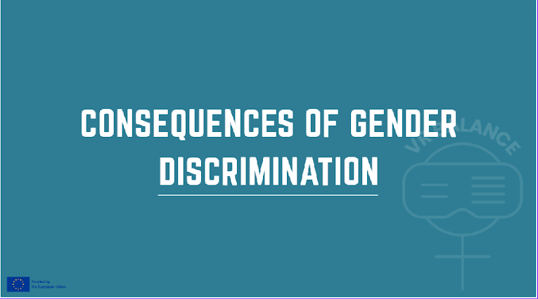
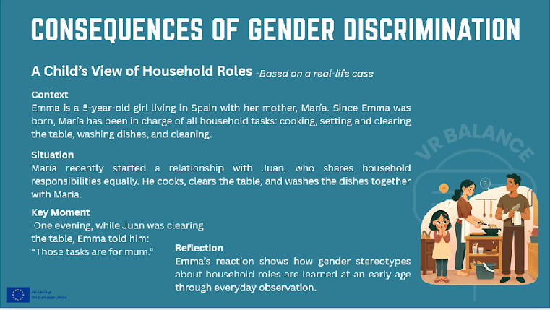
(Read the slide, explain the case)

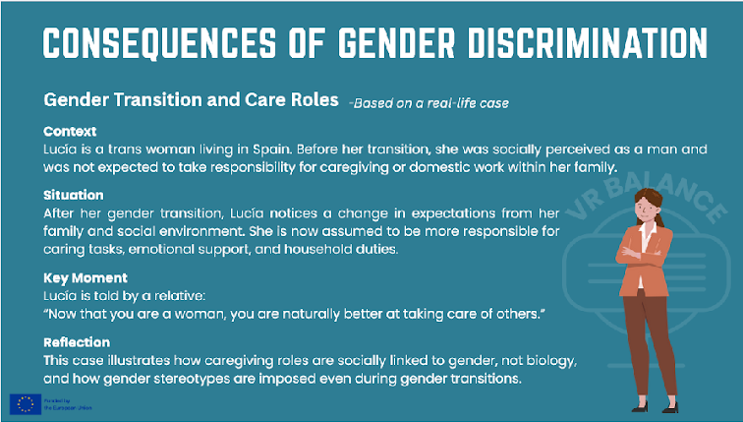
(Read the slide, explain the case)
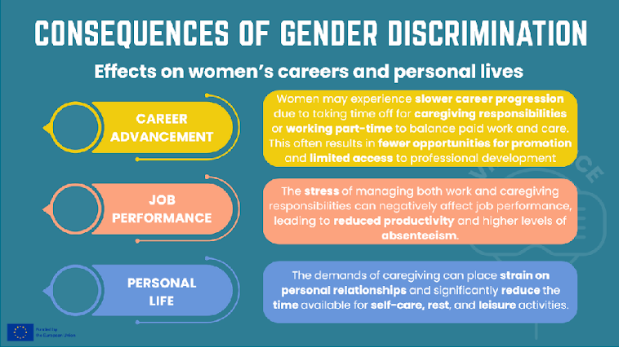
(Read the slide)
