Workshop 2
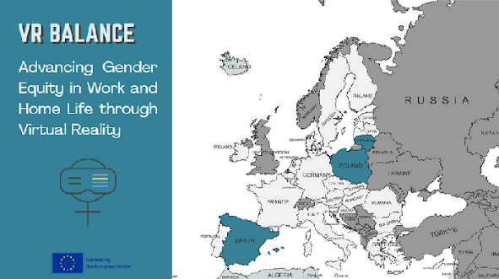
-In case it is presented as the first workshop:
Welcome everybody to the first out of three presentations that compose the VR Balance project. As you all may know, this project aims to explore gender imparities from its roots, understand social constructs of gender and the implications they have in the way of living nowadays, and encourage you to flip the script in order to make a more equal and sustainable society for all.
This project has been funded by the European Union CERV´s program, and is the result of a collaboration plan between three organization from three different countries: The Female Entrepreneurship Foundation from Poland, The Social Innovation Found from Lithuania, and The University of Barcelona in association with MetaMedics VR.
-In case is presented as the second workshop:
Use this slide while people get their seats, before welcoming back the audience.
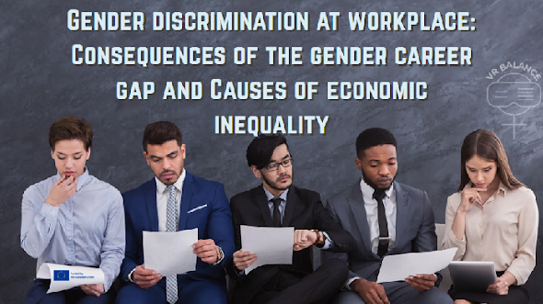
We are here to explore what lies beneath workplace inequalities—not to point fingers, but to better understand the systems we all operate within that continue to perpetuate discrimination. We will also examine the key consequences of these dynamics, including the loss of talent and the erosion of workplace culture, affecting wellbeing, innovation, and fairness.
Rememeber this: “Discrimination often operates without intent.”
Before we start:
-For PDI/PTGAS: “Who believes their workplace is fully merit-based?” (Ask for raised hands. We’ll revisit this at the end.)
-For students: Who thinks that the access for education is equal between men, women and gender non-conforming people? Have you wonder what determines this “access”?
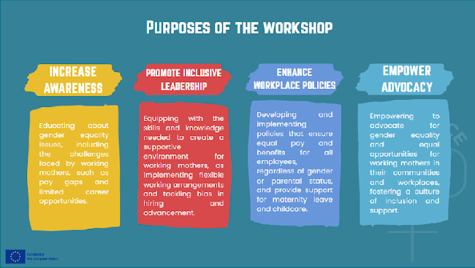
Present the objectives of the workshop
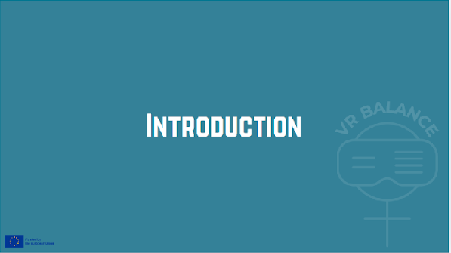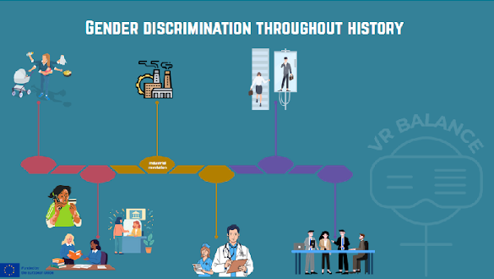
If we look at the history of work through a timeline, we can see that gender inequality does not begin because women did not work, but rather because their work was historically placed in a different position. In pre-industrial societies, both women and men worked, but under a sexual division of labor: women were primarily assigned caregiving, domestic, and life-sustaining tasks, while men were associated with productive, paid, and socially visible work. These caregiving tasks—essential for the survival of communities—were not recognized as work, either economically or socially.
Over time, this division became institutionalized. For centuries, women faced legal restrictions on access to education, property, and economic autonomy, reinforcing their dependence on the private sphere. When industrialization emerged, rather than breaking with this model, it deepened it: work became physically separated from the home, the figure of the male breadwinner and the female caregiver was consolidated, and when women entered the labor market in large numbers, they did so in feminized sectors, with lower pay and less recognition.
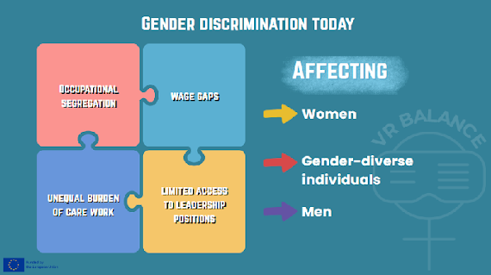
This historical model has not disappeared over time. Its effects persist today in the form of occupational segregation, wage gaps, an unequal burden of care work, and limited access to leadership positions—even in fields such as health and education, where women are the majority but do not always hold the same decision-making power. Understanding this historical trajectory allows us to recognize that current inequalities are neither accidental nor individual, but rather the result of structures that have been built and reproduced over time.
Gender discrimination can affect anyone, but historically, women are the most affected in average, gender-diverse individuals often face compounded invisibility that excludes them from society and; even though men may benefit structurally from this phenomenon, they also face norm-based penalties.
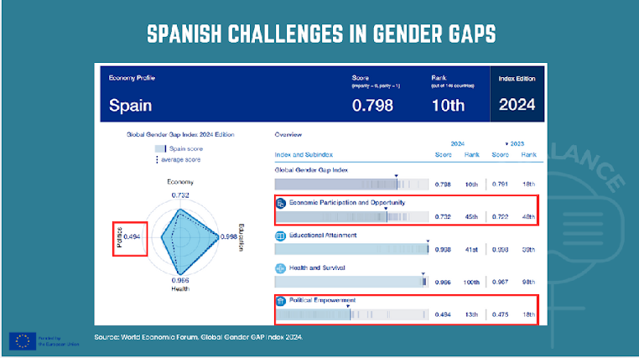
Explain the image. Although is well ranked, Spain has the challenge of improving their gender gap indexes in Economic participation and opportunity, and in Political Empowerment.
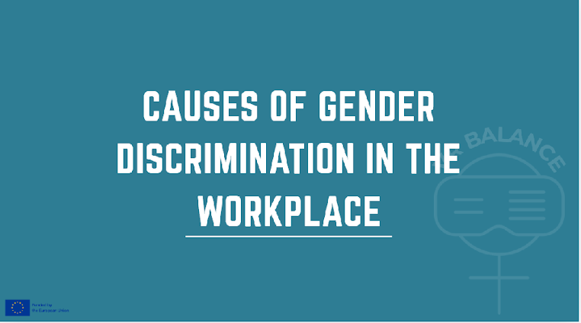
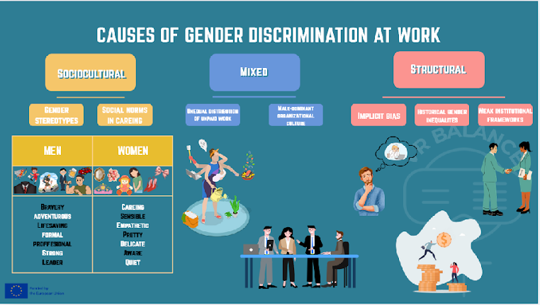
1. Sociocultural:
Job roles respond to social norms. These norms recognize gender roles and gender stereotypes, defining what is appropriate to each gender.
Where can we see these social norms? We are exposed to them since birth, and they accompany us through life, being present in our environment and on social expectations. (Use the table as an example of the construction of the social norm. The icons are the input of what we are exposed to regarding our sex, and below there are characteristic associated to them. These characteristics build the gender stereotype, and thus the gender role that will be reinforcing a future occupation.)
Example:
-Gender stereotypes 🡪 Beliefs about “female” and “male” abilities and characteristics.
-Social norms around caregiving roles 🡪 Expectation that women assume primary caregiving responsibilities.
*What if you don’t fit the gender? What if you don’t align with your expected gender role? You get to be categorized as odd and then excluded.
2. Institutional/Structural:
Refers to systemic, built-in features of organizational systems that produce and reproduce inequalities regardless of individual intentions.
Examples of these are:
-Implicit bias 🡪 Unconscious prejudices in decision-making.
-Historical gender inequalities 🡪 Accumulated gaps in human capital and networks.
-Weak institutional frameworks 🡪 Lack of regulation or enforcement.

3. Mixed:
Are those that get both socioculturaly and structuraly influenced.
-Unequal distribution of unpaid work 🡪 Disproportionate burden of domestic and care work.
-Male-dominant organizational culture 🡪 Workplace norms designed around male career patterns.
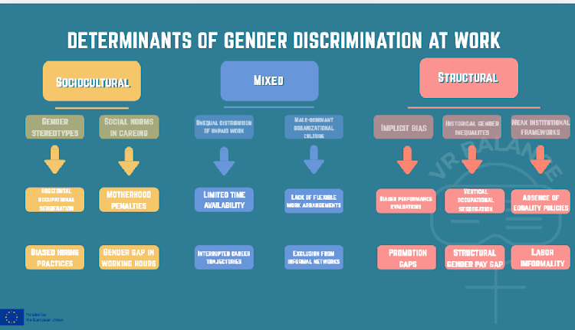
From these causes emerge various drivers of discrimination that are used to determine the impact of inequalities, understanding how the cause operates.
Examples of these are: (name just a few)
-Horizontal occupational segregation 🡪 Women concentrated in care, education, and service occupations.
-Biased hiring practices 🡪 Preference for men in STEM or technical occupations.
-Motherhood penalty 🡪 Lower wages or fewer promotions after maternity.
-Gender gap in working hours 🡪 Higher prevalence of part-time work among women.
-Limited time availability 🡪 Reduced access to managerial positions.
-Interrupted career trajectories 🡪 Temporary exits from the labor market.
-Lack of flexible work arrangements 🡪 Long working hours incompatible with caregiving.
-Exclusion from informal networks 🡪 Key decisions made in male-dominated social spaces.
-Biased performance evaluations 🡪 Women perceived as having lower leadership potential.
-Promotion gaps 🡪 Lower access to senior and executive positions.
-Vertical occupational segregation 🡪 “Glass ceiling” in higher hierarchical levels.
-Structural gender pay gap 🡪 Persistent wage differences despite similar qualifications.
-Absence of equality policies 🡪 No harassment protocols or pay transparency measures.
-Labor informality 🡪 Higher female concentration in precarious employment.
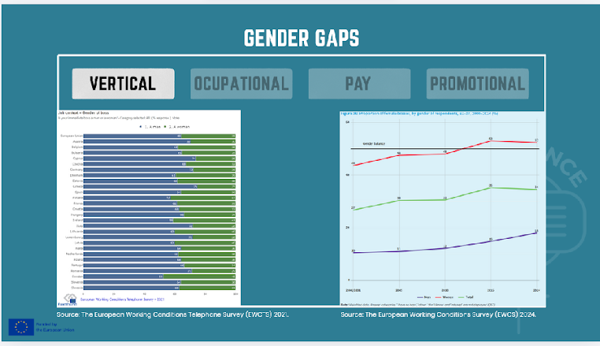
At the workplace, there are 4 main Gender gaps to pay attention to:
-Vertical gap: which is the unequal distribution of women and men across hierarchical levels within organizations/occupations.
Data from The European Working Conditions Telephone Survey (EWCTS) 2021 showed that almost a 1/3 of the manager positions of the people asked, where men.
Data from The European Working Conditions Survey (EWCS) 2024 indicates:
Minimal progress has been made towards gender balance at management level over the past 25 years. The proportion of female managers increased from 27 % in the 2000/2001 survey to 34 % in 2024 (Figure 36). However, female managers continue to be concentrated in female-dominated workplaces, where gender composition of immediate bosses has reached parity. Women are hereby much more likely to have a female boss (52 %) than men are (18 %).
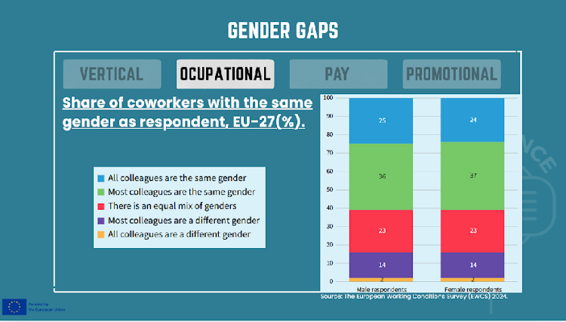
-Horizontal/Occupational gap: which describes concentration of male/females among different types of jobs or occupations, tending to have over and underrepresentation in some fields.
Data from The European Working Conditions Survey (EWCS) 2024: Increasing female participation has contributed to a narrowing of gender gaps in some sectors and occupations, but not all. The context is one of persistent gender segregation of employment. This is not only true when looking at sectors and occupations, but also in the workplace. A gender-balanced workplace remains the exception, with only 23 % of workers reporting that they work in workplaces where about half of the workforce is female (Figure 35).
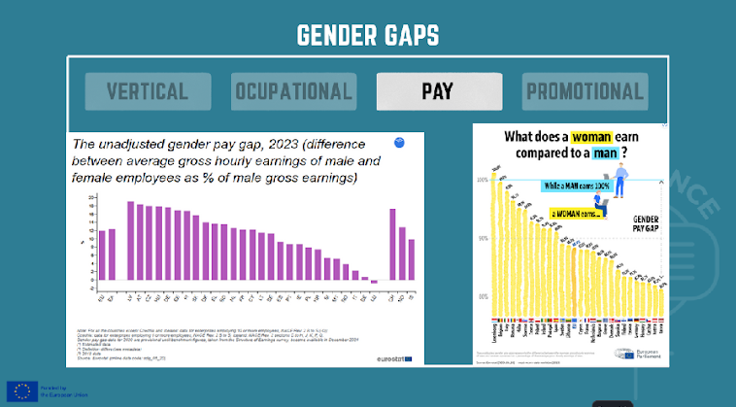
-Pay gap: refers to the average difference in earnings between women and men, expressed as a percentage of men’s earnings.
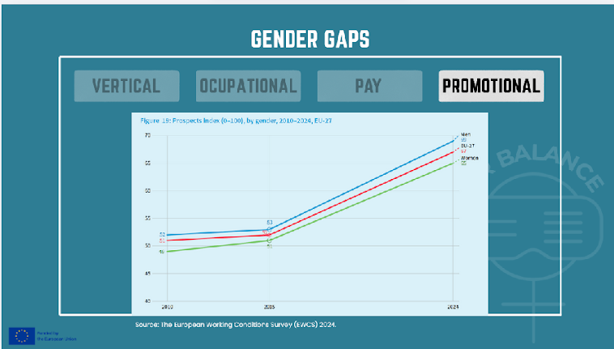
-Promotional gap: refers to gender differences in rates of promotion and career progression.
Progress over time: Two of the items in the Prospects index that can be used to examine trends over time are career prospects and job security (which addresses fear of job loss). In the context of a much-improved labour market, the Prospects index has improved significantly since 2010 for both men and women. However, the gender gap has increased since 2015 (Figure 19).
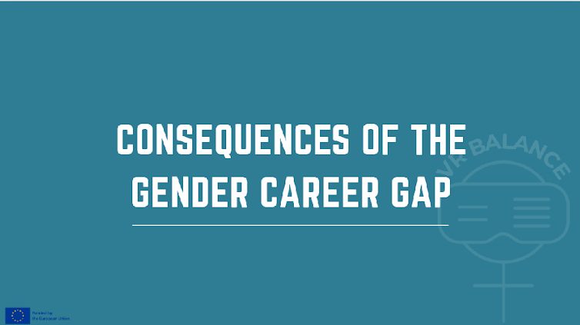
There are Individual, organizational and societal consequences of the gender gap, and that together impact drastically on the economy.
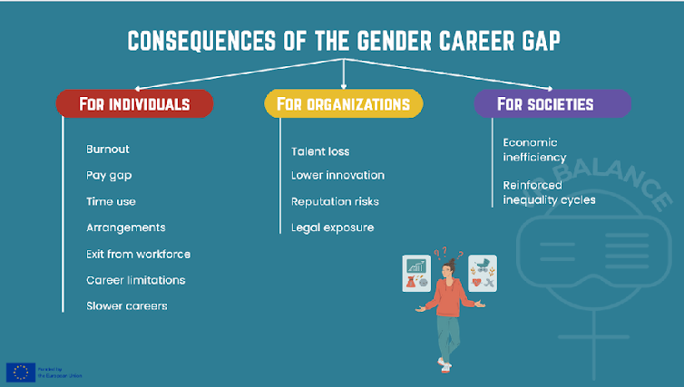
For Individuals
- Slower careers/ Career limitations
- Burnout: Time use: also associated with family and child care; Caring jobs: elderly and disabled people
- Self-censorship
- Exit from workforce
- Pay gap: pay gap and marital status
- Arrangements: flexible hours of work
For Organizations
- Talent loss
- Lower innovation
- Reputation risks
- Legal exposure
For Society
- Economic inefficiency
- Reinforced inequality cycles
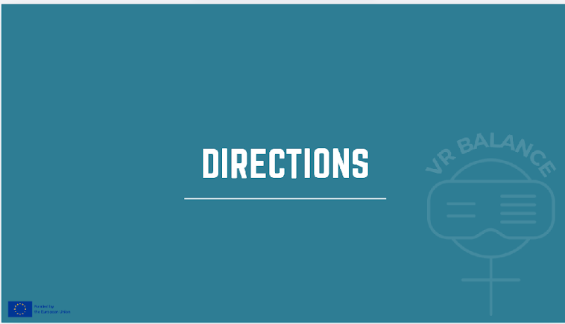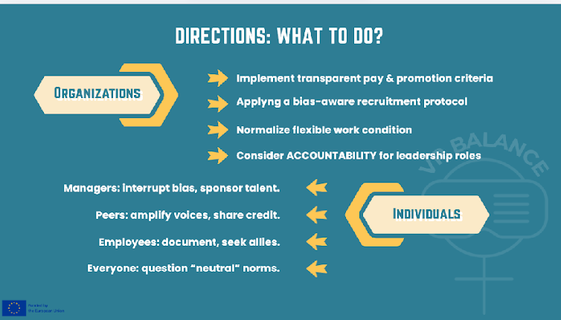
6.2 What Organizations Can Do
- Transparent pay & promotion criteria
- Bias-aware recruitment
- Flexible work normalization
- Accountability for leadership
6.3 What Individuals Can Do (by role)
- Managers: interrupt bias, sponsor talent
- Peers: amplify voices, share credit
- Employees: document, seek allies
- Everyone: question “neutral” norms
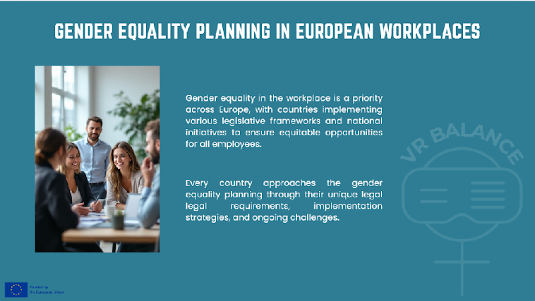
Gender equality in the workplace is a priority across Europe, with countries implementing various legislative frameworks and national initiatives to ensure equitable opportunities for all employees.
Every country approaches the gender equality planning through their unique legal legal requirements, implementation strategies, and ongoing challenges.
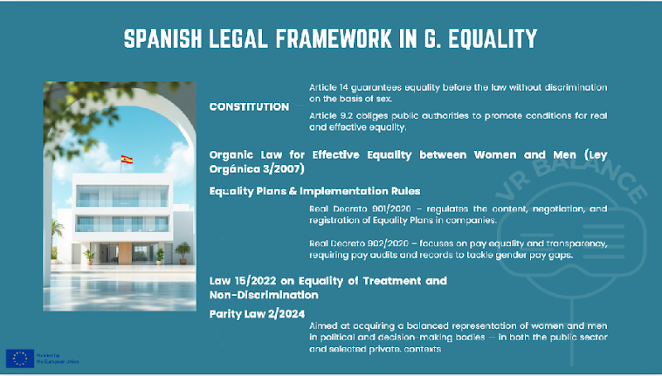
1- Constitution of Spain, through different articles dictates:
Article 14 guarantees equality before the law without discrimination on the basis of sex.
Article 9.2 obliges public authorities to promote conditions for real and effective equality.
2- Organic Law for Effective Equality between Women and Men (Ley Orgánica 3/2007)
It establishes: The principle of equal treatment and opportunities; Obligations for employers and public administrations to prevent discrimination and promote equality; Mandatory Equality Plans for companies with a certain number of employees; Measures against sexual harassment and discriminatory practices.
3- Equality Plans & Implementation Rules: Two Royal Decrees implement and regulate workplace equality obligations under the 2007 law:
Real Decreto 901/2020 – regulates the content, negotiation, and registration of Equality Plans in companies.
Real Decreto 902/2020 – focuses on pay equality and transparency, requiring pay audits and records to tackle gender pay gaps.
4- Law 15/2022 on Equality of Treatment and Non-Discrimination
Broader legal protection against discrimination on various grounds, including gender, in employment, education, access to goods/services, and public life. It complements the Organic Equality Law by strengthening anti-discrimination guarantees.
5- Parity Law 2/2024
Aimed at acquiring a balanced representation of women and men in political and decision-making bodies — in both the public sector and selected private contexts. It implements EU requirements about gender balance and extends them beyond the minimum thresholds.
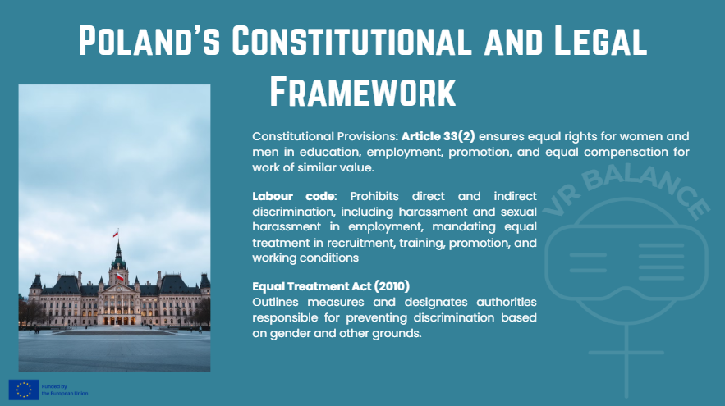
Constitutional Provisions: Article 33(2) ensures equal rights for women and men in education, employment, promotion, and equal compensation for work of similar value.
Labour code: Prohibits direct and indirect discrimination, including harassment and sexual harassment in employment, mandating equal treatment in recruitment, training, promotion, and working conditions.
Equal Treatment Act (2010): Outlines measures and designates authorities responsible for preventing discrimination based on gender and other grounds.

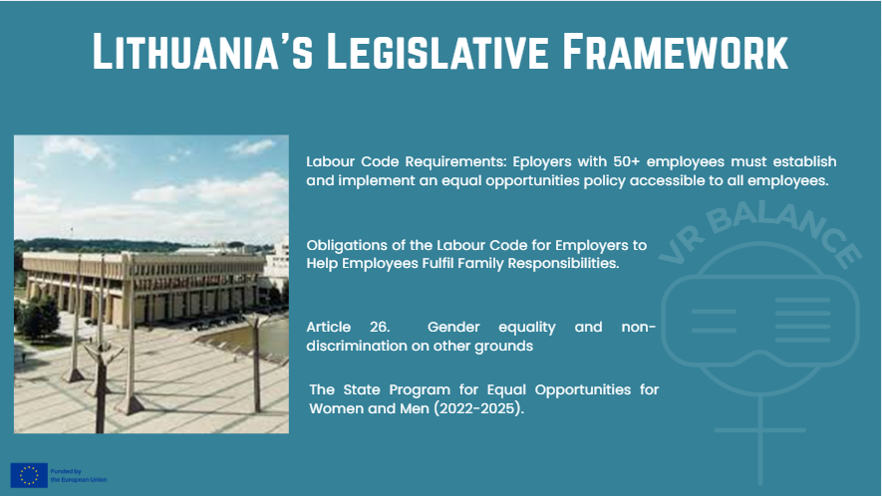
Labour Code Requirements: Eployers with 50+ employees must establish and implement an equal opportunities policy accessible to all employees.
Obligations of the Labour Code for Employers to Help Employees Fulfil Family Responsibilities. Labour Code of the Republic of Lithuania Article 28. respect for the employee's family obligations: The employer shall take measures to assist the employee in fulfilling his/her family obligations. In the cases provided for in this Code, requests made by employees relating to the fulfilment of family obligations shall be considered by the employer and shall be answered in writing with reasons. The conduct of the employee and his/her actions at work shall be evaluated by the employer with a view to the practical and full implementation of the principle of work-family balance.
Article 26. Gender equality and non-discrimination on other grounds.
The State Program for Equal Opportunities for Women and Men (2022-2025). It establishes a comprehensive framework addressing multiple priority areas. While this specific program has concluded, Lithuania continues to prioritize gender equality through ongoing legislative measures and new initiatives.
